INFO 3440- AKIPRO BAKERY

   Moniece Forbes-Wells | Usha Mungal ROHINI CYNTHIA BABOOLAL| Kris Chinaikan

Requirements documents

**Table of Contents**

**The Delivery Module** 2

System Requirements: 3

Data Flow Diagram 3

Entity Relationship Diagram 5

Sequence Diagrams 6

Sequence Diagram for printing an invoice 7

Activity Diagram 10

Use Cases 15

Resource Diagrams 22

**The Customer Accounts Module** 23

System Requirements: 23

Data Flow Diagram 24

Entity Relationship Diagram 26

Sequence Diagrams 27

Activity Diagrams 32

Use Cases 37

Resource Diagram: Customer Accounts 42

Interface Design Screenshots 43

**The Merchandiser Module:** 46

System Requirements: 46

Data Flow Diagram 47

Entity Relationship Diagram 48

Sequence Diagram 49

Activity Diagram 50

Interface Design Screenshots 51-54

# **The Delivery Module**

**User Requirements:**

1. Driver must be able to connect to database in order to retrieve orders associated with driver’s assigned route
2. Driver must be able to generate invoices
3. Driver must be able to make returns
4. Driver must be able to make sales on the spot

## **System Requirements:**

1. System should be able to authorize driver
2. System should be able to sync invoices from database to driver’s account on remote device
3. System should be able to provide listing and details of individual invoices for driver’s use
4. System should have mechanisms in place for drivers to record returns made to invoices
5. System should have procedures in place for drivers to be able to record all cash purchases

## **Data Flow Diagram**

## 

## 











## **Entity Relationship Diagram**

## 

## **Sequence Diagrams**

Sequence Diagram for viewing all invoices



## Sequence Diagram for printing an invoice



Sequence Diagram for Logging in



Sequence Diagram for recording a cash purchase



Sequence Diagram for recording returns



## **Activity Diagram**

Activity Diagram for Logging in and Returning products



**Activity Diagram for Recording a Cash Purchase**



Activity Diagram for viewing all Invoices



Activity Diagram to view one invoice



# **Use Cases**

|  |  |
| --- | --- |
| Use Case Number | 1 |
| Use Case Name | Driver’s Login |
| Related Requirements | Must know login and password |
| Goal | Successful login |
| Pre-Conditions | Must have delivery app and logon credentials |
| Successful | User being successful in logging on to app |
| Fail End Condition | User being unsuccessful in logging in to app |
| Primary Actor | Driver |
| Secondary Actor | Manager |
| Main Flow | 1. User opens application 2. User is then prompted to enter credentials 3. User enters ID and password 4. User is then redirected to main menu |

|  |  |
| --- | --- |
| Use Case Number | 2 |
| Use Case Name | Returns for an order |
| Related Requirements | Must know the order associated with the product that is being returned |
| Goal | Successfully recording returns on an order |
| Pre-Conditions | Order must exist in order to make changes to it |
| Successful | Successfully add returns to an order |
| Fail End Condition | Unsuccessful in adding returns to an order |
| Primary Actor | Driver |
| Secondary Actor | Manager |
| Main Flow | 1. User opens application 2. User enters credentials 3. User is directed to main menu 4. User then selects the option for returns on an invoice 5. User is then prompted to enter customer info and date of invoice associated with product to be returned 6. User enters data 7. User then views the associated invoice 8. The quantity of the product/s being returned is entered into the return column of the order 9. User then clicks the save button 10. User is then redirected to the main menu |

|  |  |
| --- | --- |
| Use Case Number | 3 |
| Use Case Name | Recording a cash purchase |
| Related Requirements | User must have app |
| Goal | Successfully recording a cash purchase |
| Pre-Conditions | User must know the products being purchased and its quantity |
| Successful | Successful in recording a cash purchase |
| Fail End Condition | Unsuccessful in recording a cash purchase |
| Primary Actor | Driver |
| Secondary Actor | Manager |
| Main Flow | 1. User opens application 2. User enters credentials 3. User is directed to main menu 4. User then selects the recording a cash purchase option 5. User is then directed to a page where customer info, items being purchased and its quantity is entered 6. User then enters the data 7. User then clicks the save button 8. User is then redirected to main menu page |

|  |  |
| --- | --- |
| Use Case Number | 4 |
| Use Case Name | Viewing a list of all invoices for assigned route and also the details of individual invoice |
| Related Requirements | -- |
| Goal | Successfully viewing all invoices for assigned route |
| Pre-Conditions | User must have app |
| Successful | Successful in viewing the invoices |
| Fail End Condition | Unsuccessful in viewing the invoices |
| Primary Actor | Driver |
| Secondary Actor | Manager |
| Main Flow | 1. User opens application 2. User enters credentials 3. User is directed to main menu 4. User then selects the view list of all invoices options 5. User is directed to a page that displays a list of all invoices for the day 6. If the user wants to view an individual invoice, user simply clicks on the invoice to view it. |

|  |  |
| --- | --- |
| Use Case Number | 5 |
| Use Case Name | View details of one invoice |
| Related Requirements | -- |
| Goal | Successfully view an invoice |
| Pre-Conditions | Must know the name of the company invoice is associated with |
| Successful | Successful in viewing the invoice |
| Fail End Condition | Unsuccessful in viewing the invoice |
| Primary Actor | Driver |
| Secondary Actor | Manager |
| Main Flow | 1. User opens application 2. User enters credentials 3. User is directed to main menu 4. User then selects the view invoice for one customer option 5. User is then prompted to enter the customer name 6. Invoice for customer for current day is retrieved and made available for the user |

|  |  |
| --- | --- |
| Use Case Number | 6 |
| Use Case Name | Print invoice |
| Related Requirements | -- |
| Goal | Print invoice successfully |
| Pre-Conditions | Must know the customer name in order to find the correct invoice to print |
| Successful | Invoice was printed successfully |
| Fail End Condition | Invoice encountered an error and was not printed |
| Primary Actor | Driver |
| Secondary Actor | Customer |
| Main Flow | 1. User opens application 2. User enters credentials 3. User is directed to main menu 4. User then selects the view list of all invoices option or the record a cash purchase option or the view one invoice option 5. User then views required invoice 6. User then verifies information and clicks the print button. |

|  |  |
| --- | --- |
| Use Case Number | 7 |
| Use Case Name | Syncing outstanding transaction with database |
| Related Requirements | User must be logged on |
| Goal | Successfully syncing with database |
| Pre-Conditions | Must have an internet connection |
| Successful | Successful in syncing with database |
| Fail End Condition | Unsuccessful in syncing with database |
| Primary Actor | Driver |
| Secondary Actor | Manager |
| Main Flow | 1. User opens application 2. User enters credentials 3. User is directed to main menu 4. User clicks sync button |

## **Resource Diagrams**

Resource Diagram: Invoices

|  |  |  |  |
| --- | --- | --- | --- |
| Action | Input Parameter | Output | Description |
| Get | Customer name, token | Invoice number, customer number, items | A list of items of invoice for a customer is returned |
| Post | Operation, token | A JSON object with a string to show status of request | Operation can be equal to recording returns for an order |
| Put | Customer name, items, date, token | A JSON object with a string to show states of requests. | Invoice is added to the invoices table of the database. |
| Delete | Invoice day, token | A JSON object with a string to show states of requests | Delete all |

## User Interface Screenshots

**Login page for delivery app**

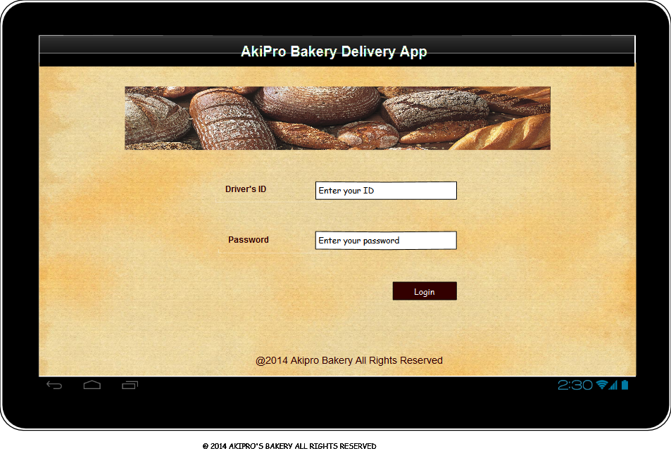

**Home page for Delivery App**

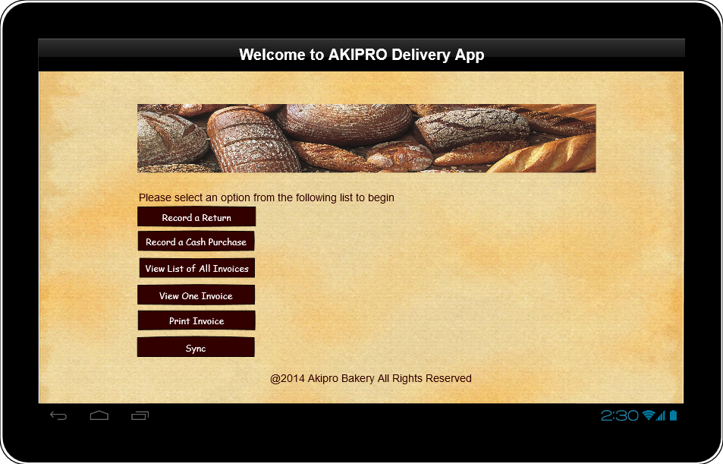

**Recording a cash purchase on the Delivery App**

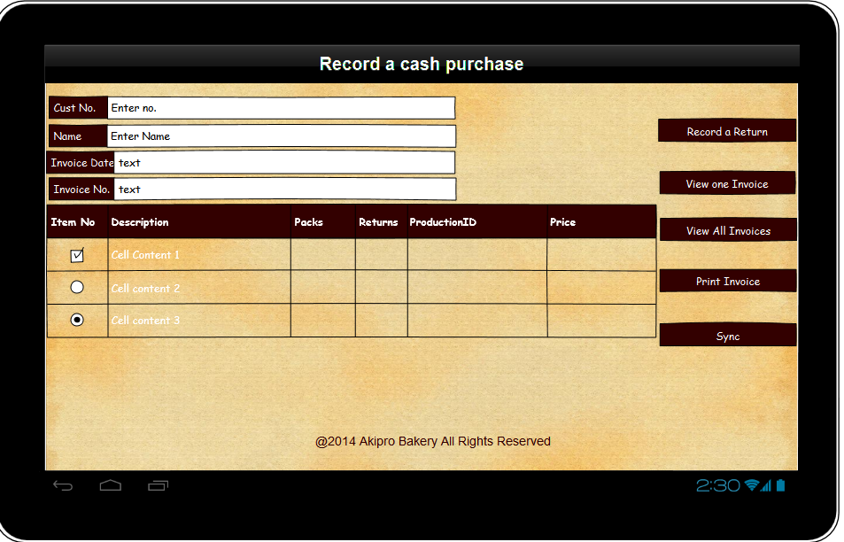

**Recording returns on the Delivery App**

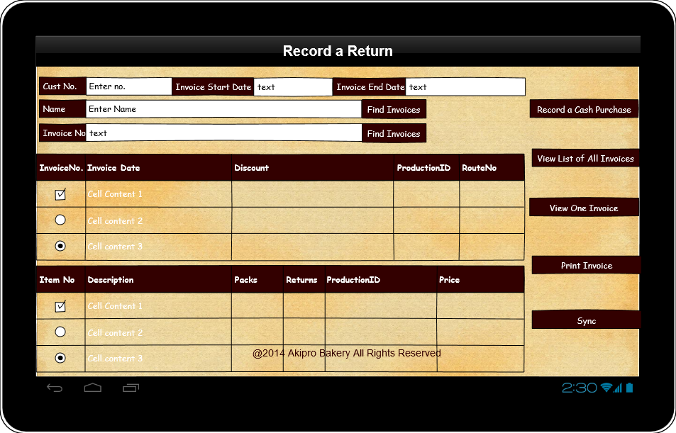

**Viewing a list of all invoices in the Delivery App**

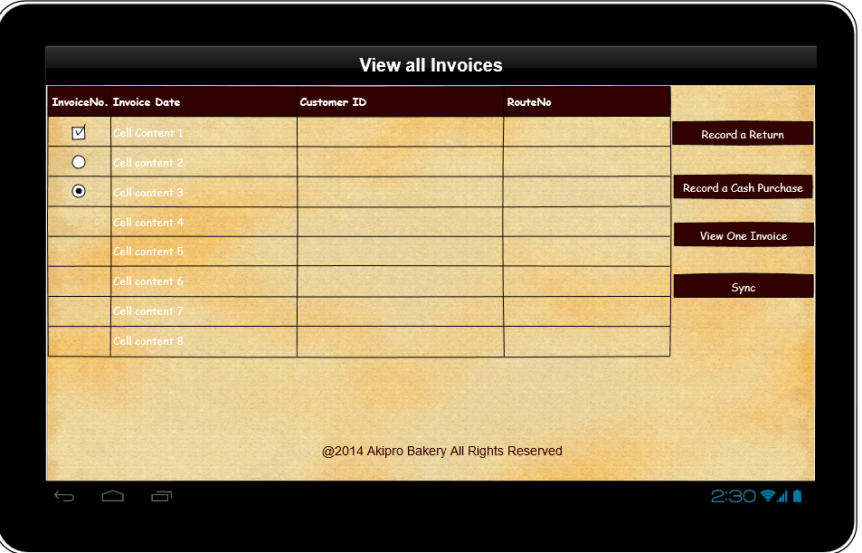

**Viewing one invoice in the Delivery App**

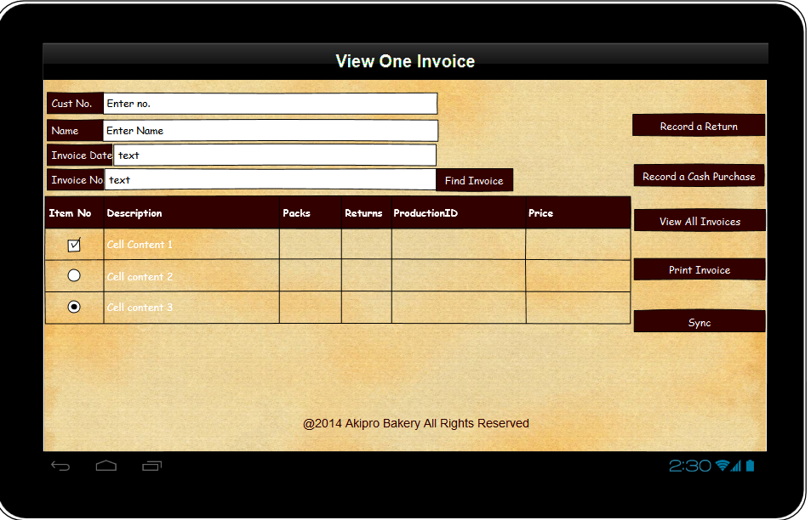

**Printing page on the Delivery App**

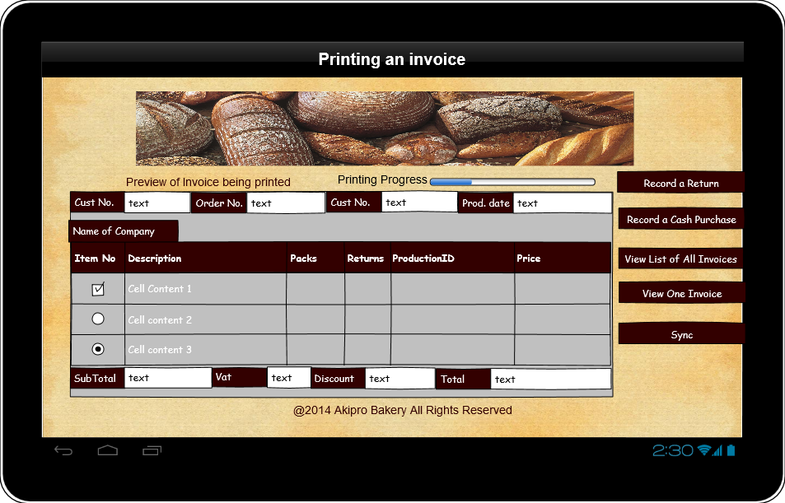

**Syncing page on Delivery App**

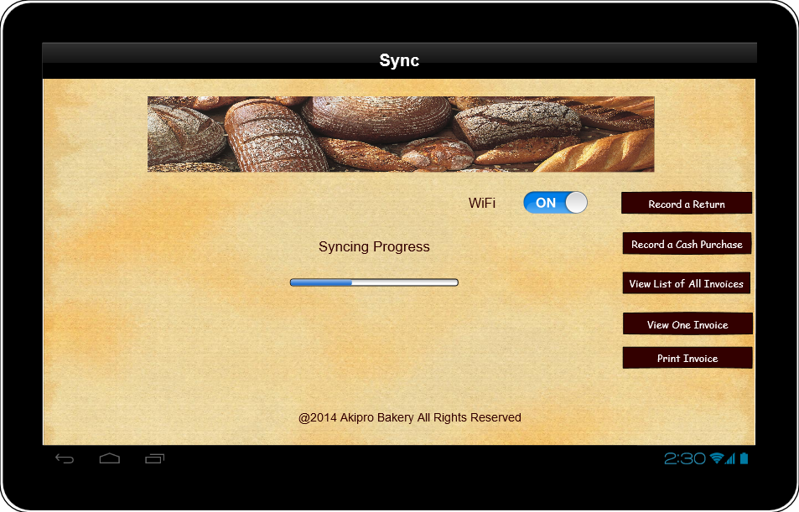

# **The Customer Accounts Module**

User Requirements:

1. The customer shall be able to view all activities being done to their account.
2. The customer shall be able to print statements directly from their account
3. The customer shall be able to request changes to their standing orders.
4. The customer shall be able to view their order history and also pending orders for their account.

## System Requirements:

1. System should be able to grant customers access to login
2. System should be able to provide the customer’s order(s) via their account
3. System should have mechanisms in place for the customer to view their transactions
4. System should have mechanisms in place for customers to request a change in their order.
5. System should have procedures in place for customers to be able to print their statements

## **Data Flow Diagram**











## **Entity Relationship Diagram**



## **Sequence Diagrams**

Sequence diagram to request to be a Customer



Sequence diagram to become a Customer



Sequence diagram to log into Customer Account



Sequence diagram to create a standing order



Sequence diagram to change standing order



## **Activity Diagrams**

Activity Diagram to Request to be a Customer



Activity Diagram to create Customer online account



Activity diagram to log into a Customer Account



Activity diagram to create a standing order



Activity diagram to change a standing order



# **Use Cases**

|  |  |
| --- | --- |
| Use Case Number:- | 1 |
| Use Case Name | Request to be a Customer |
| Related Requirements | Must meet expected requirements of the company to be a customer on their system |
| Goal | To become a customer |
| Pre-Conditions | Must have a good credit history |
| Successful | User being successful in becoming a customer |
| Fail End Condition | Customer being unsuccessful in approval to be a customer |
| Primary Actor | Customer |
| Secondary Actor | Office Staff |
| Main Flow | 1. Customer sends a request letter 2. Office staff receive it 3. Office staff reviews customer background with the necessary authorities 4. Office staff approves/disprove 5. Office Staff notifies the customer |

ss

|  |  |
| --- | --- |
| Use Case Number:- | 2 |
| Use Case Name | Create Customer Account |
| Related Requirements | Must be approved by Office Staff to create and account |
| Goal | Creating online customer account |
| Pre-Conditions | * Must be approved by office staff to be a customer. * Must be an active customer to have an account. * Must meet particular criteria to be qualified to be a customer. |
| Successful | Customer successful in creating their account |
| Fail End Condition | Customer being unsuccessful in creating their account |
| Primary Actor | Customer |
| Secondary Actor | Office Staff |
| Main Flow | 1. Customer receives approval for account. 2. Customer opens search engine of their choice 3. Customer types is the URL for the bakery 4. Customer clicks on register 5. Customer enters their information 6. Customer is then directed to the main menu |

|  |  |
| --- | --- |
| Use Case Number:- | 3 |
| Use Case Name | Customer Login |
| Related Requirements | Must know login and password |
| Goal | Successful login |
| Pre-Conditions | Must have a customer account |
| Successful | Customer being successful in logging into their account |
| Fail End Condition | Customer being unsuccessful in logging into their account |
| Primary Actor | Customer |
| Secondary Actor | Office Staff |
| Main Flow | 1. Customer opens search engine of their choice 2. Customer types is the URL for the bakery 3. Customer clicks on login 4. Customer enters their username and password 5. Customer is then directed to the main menu |

|  |  |
| --- | --- |
| Use Case Number:- | 4 |
| Use Case Name | Create a Standing Order |
| Related Requirements | Customer must know their username and password. |
| Goal in Context | Add standing order to customer account |
| Pre-Conditions | Must have a customer account |
| Successful | Customer was successful in adding a standing order to their account. |
| Fail End Condition | Customer was unsuccessful in creating a standing order. |
| Primary Actor | Customer |
| Secondary Actor | Office Staff |
| Main Flow | 1. Customer logins into their account using login credentials. 2. Customer clicks create standing order 3. Customer fills out the form 4. Customer saves the standing order. |

|  |  |
| --- | --- |
| Use Case Number:- | 5 |
| Use Case Name | Change to Standing Order |
| Related Requirements | Must know CustId, StandingOrderNo |
| Goal in Context | Making a change to standing order |
| Pre-Conditions | Must be a customer and have an account |
| Successful | Customer was successful in approval to change their standing order |
| Fail End Condition | Customer was unsuccessful in getting their standing order changed. |
| Primary Actor | Customer |
| Secondary Actor | Office Staff |
| Main Flow | 1. Customer writes a letter of request to make a change to standing order. 2. Office Staff receives it and approves 3. Customer receives approval notification 4. Customer standing order changed |

## **Resource Diagram: Customer Accounts**

|  |  |  |  |
| --- | --- | --- | --- |
| Action | Input Parameter | Output | Description |
| Get | Customer name, token | customer number, customer name | Customer info is returned |
| Post | Operation, token | A JSON object with a string to show status of request | Operation can be equal to recording customer info and customer payment |
| Put | Customer name, standingOrderDate, token | A JSON object with a string to show states of requests. | Standing order is added to the standing order table of the database |
| Delete | Standing orders, token | A JSON object with a string to show states of requests | Delete all |

# **Interface Design Screenshots**

The snapshot below shows the welcome page when a customer goes onto the AkiPro Bakery website

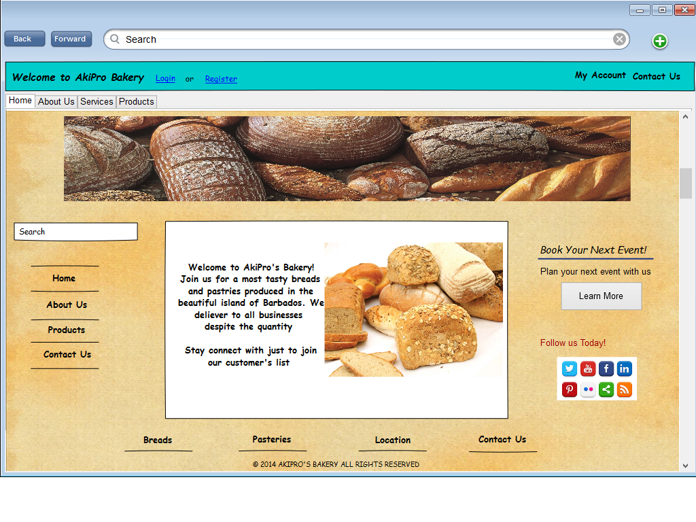

The snapshot below shows the login page when the customer clicks on login on the AkiPro Bakery website

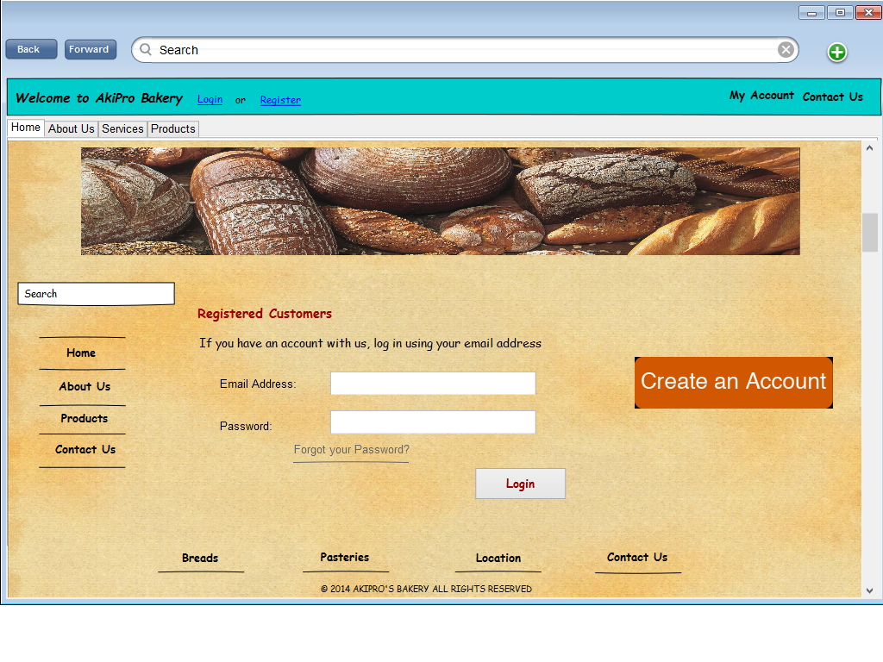

The snapshot below shows the Register for a customer to create and account on the AkiPro Bakery website

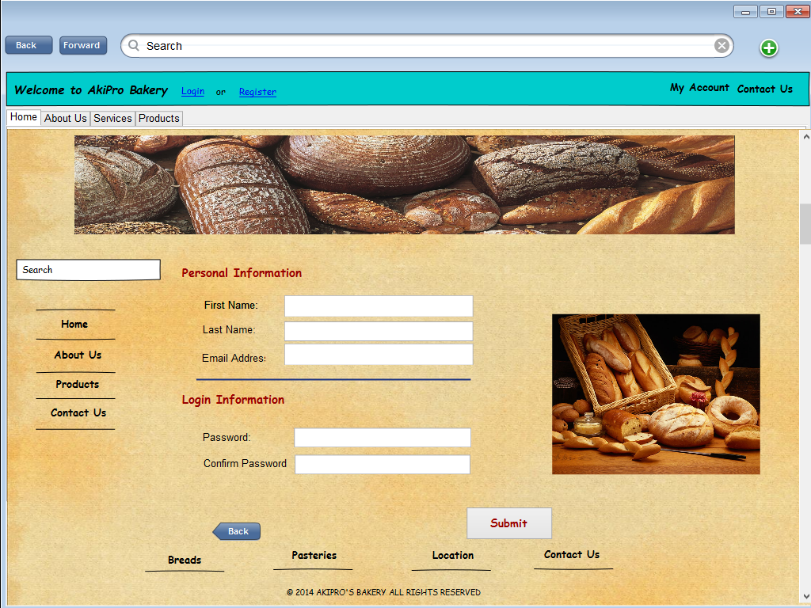

The snapshot below shows the page for a customer to create a standing order for their account page on the AkiPro Bakery website

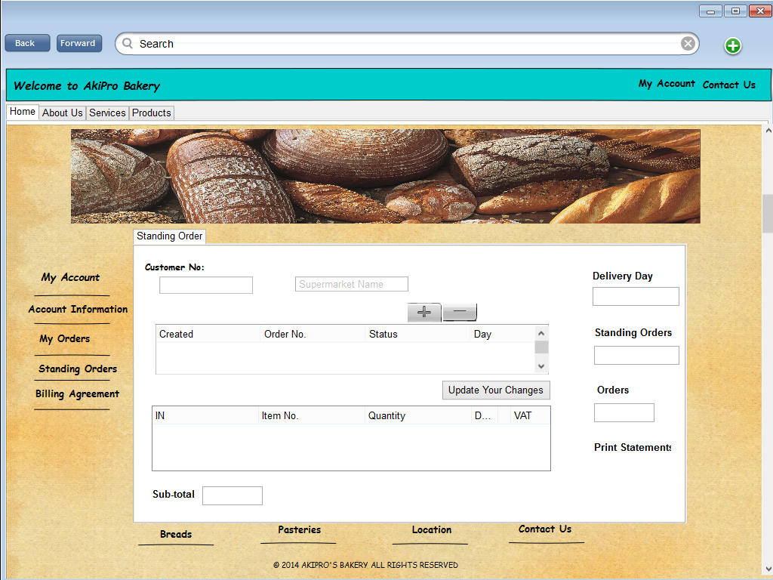

# **The Merchandiser Module:**

User Requirements:

1. Merchandiser should be able to login into the system to gain access to customer information and standing orders.
2. Merchandiser should be able to generate sales reports for a customer
3. Merchandiser should be able to make changes to the standing order for authorization.
4. Merchandiser should be able to make comments on a sales report that is generated.

## System Requirements:

1. System should be able to authorize the merchandiser
2. System should be able to generate sales reports.
3. System should be able to allow merchandiser to make comments on sales reports.
4. System should have mechanisms in place for merchandiser to make changes to standing order and submit the changes for approval.
5. System should notify the customer when a change is made to their standing order.

## **Data Flow Diagram**



# **Entity Relationship Diagram**



# **Sequence Diagram**



# **Use Cases**

|  |  |  |  |
| --- | --- | --- | --- |
| Use Case Name | Modify Standing Order | | |
| Requirements | Standing order must exist | | |
| Related Requirements | The customer for the standing order must exist | | |
| Goal in Context | Submit changes for changes to standing order | | |
| Pre-Conditions | Merchandiser must have access to the system | | |
| Successful End Condition | Changes to standing order sent for approval | | |
| Fail End Condition | Changes to standing order cannot be made | | |
| Primary Actor | Merchandiser | | |
| Secondary Actor | Administrative staff | | |
| Trigger | - | | |
| Main Flow | Step |  | Action |
|  | 1 |  | Log into system |
|  | 2 |  | Select customer search |
|  | 3 |  | Enter customer name |
|  | 4 |  | View customer information |
|  | 5 |  | Request sales report |
|  | 6 |  | View sales report |
|  | 7 |  | Make comments on sales report |
|  | 8 |  | Make changes to standing order |
|  | 9 |  | Submit changes for approval |
|  | | | |

**User Interfaces**

**Login Screen from merchandiser application:**

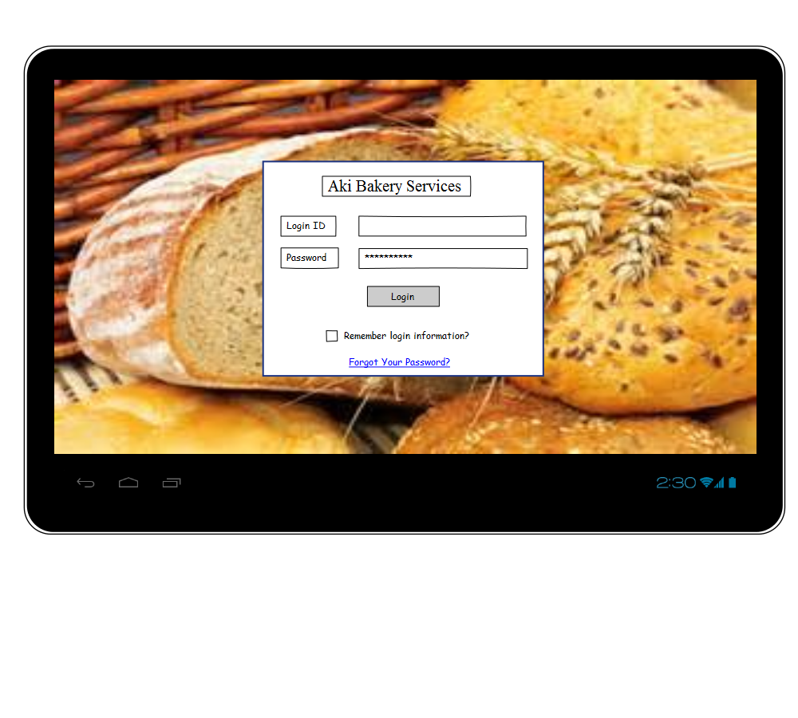

**Merchandiser home page:**

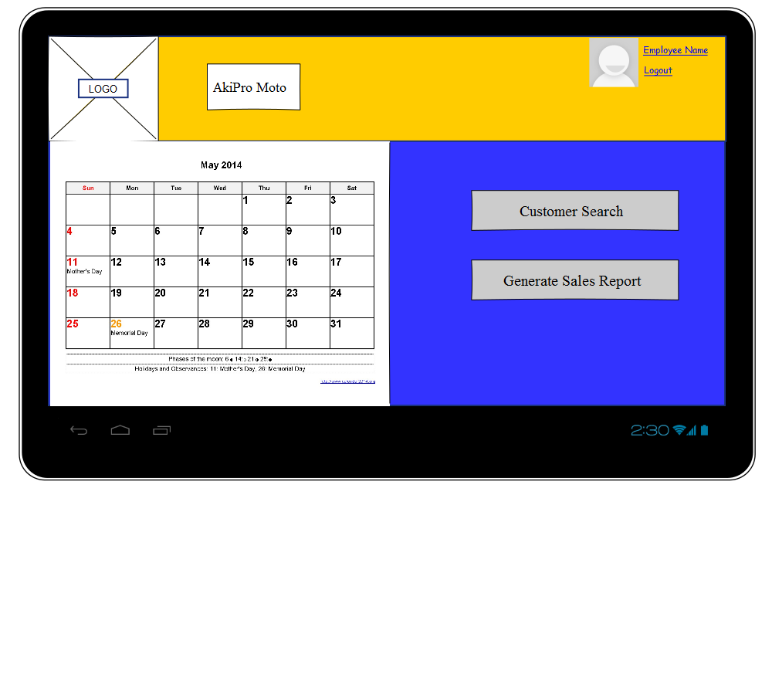

**Customer Search from merchandiser application:**

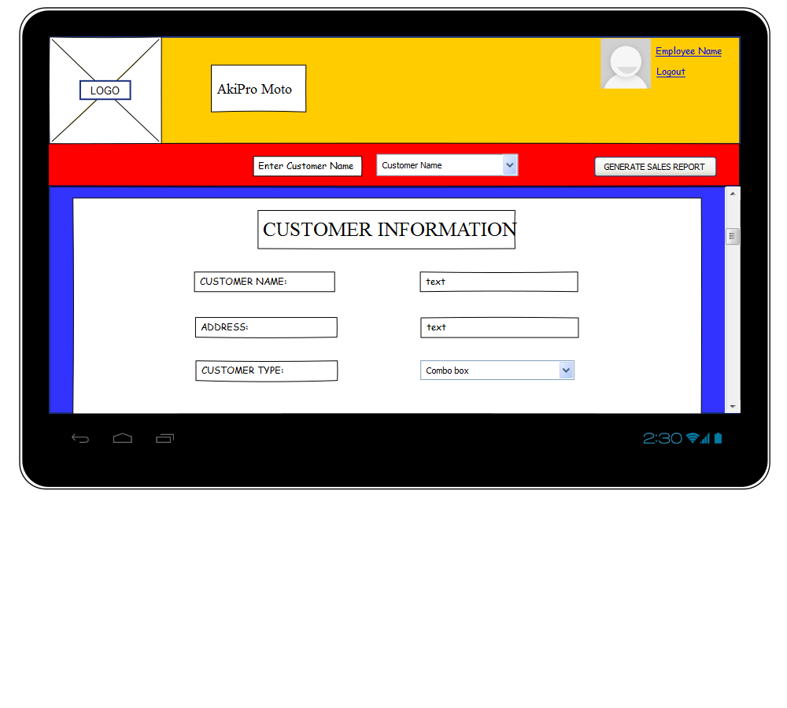

**Generating Sales Report and allowing for comments:**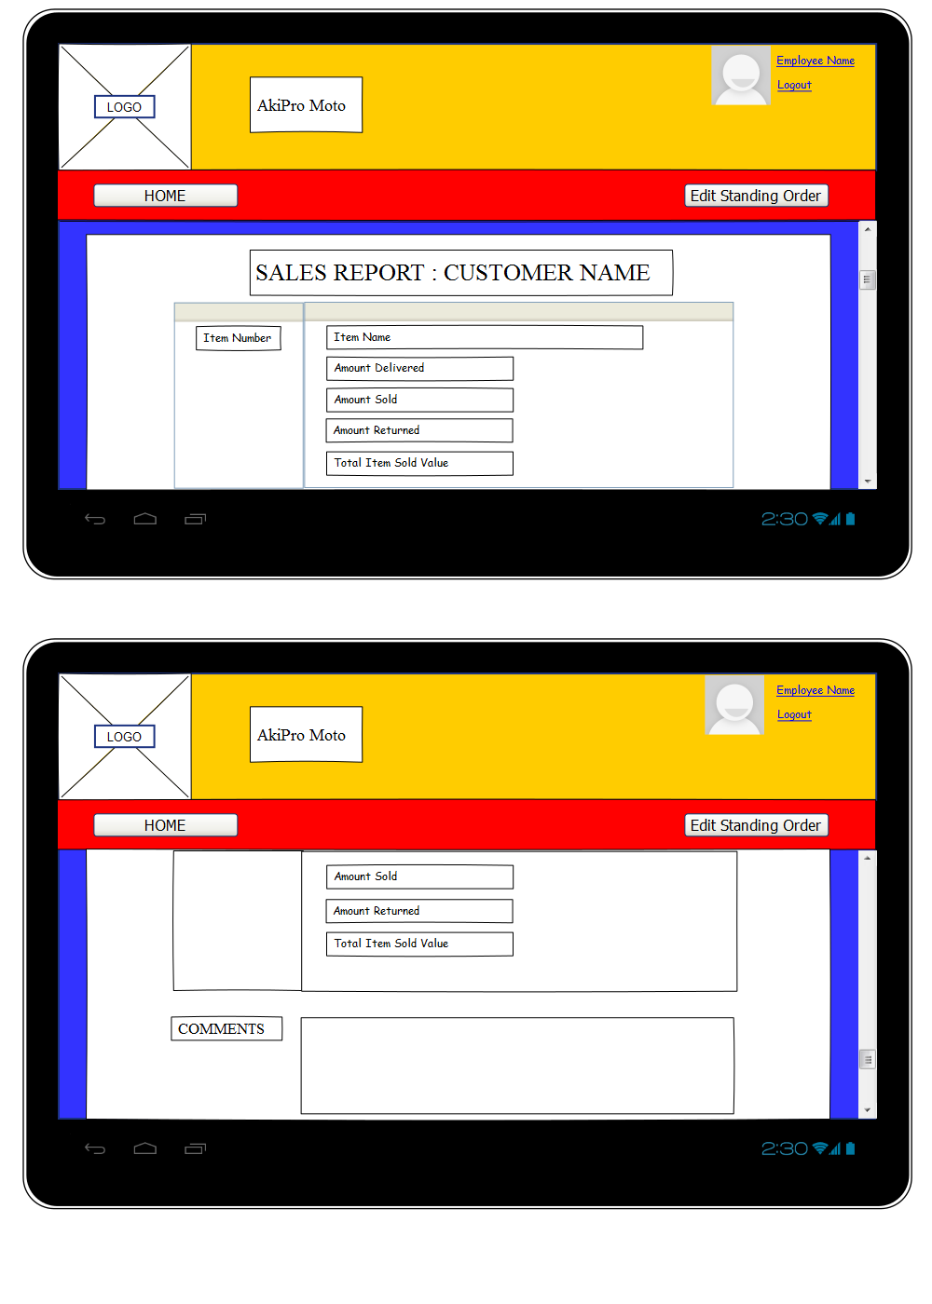

**Editing Standing order from Merchandiser application for approval submission:**